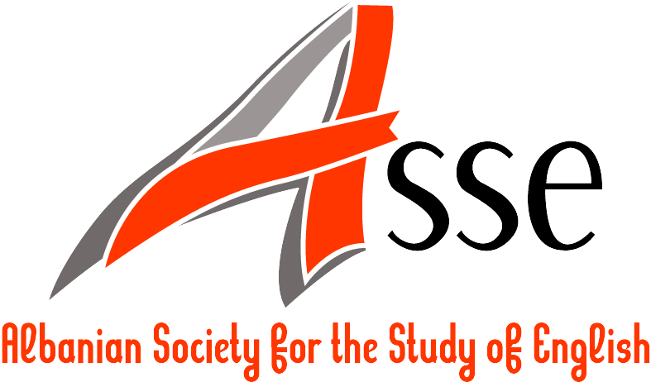

Albanian Society for the Study of English (ASSE)
http://www.assenglish.org
asse@assenglish.org

Registration Form

Only connect …

FIRST ASSE INTERNATIONAL CONFERENCE ON BRITISH AND AMERICAN STUDIES

11-13 June 2011

Hosted by
Department of Foreign Languages, Faculty of Humanities, University of Vlora “Ismail Qemali”, Albania

Please complete the registration form and return it by e-mail by 10 May 2011 to the following e-mail address: onlyconnect@assenglish.org

- Participant’s Information

Family name:
First name(s):
Title:
Affiliation:
Address:
E-mail address:
Phone number(s):

- Travel Information*

Arrival date:
Departure date:
Flight:
Other:

* We need this information to make our provisions for those participants flying from their country destinations to Tirana in order to pick them up at the airport.

- Conference Information

Are you presenting a paper? | YES  NO   (If YES, please provide the title of your presentation):
Are you willing to chair a session? | YES  NO 
Do you have any special equipment requirements for your presentation? | YES  NO   (If YES, please specify the equipment):
How did you learn about this conference? (We would appreciate it very much if you could provide us with this information.) | Conference Alerts   Linguist List   Papers Invited   ESSE website   All Conferences   H-Net   E-mail   Other 

- Conference Fee* (Please indicate by ticking the appropriate box)

Please note that scholars may send up to two abstracts for consideration, and if accepted, they are requested to pay a regular fee for each of them. Also, co-authors are requested to pay full conference fee, even if they might not attend the conference.

Early registration regular (80 euros) | 
Early registration ASSE Members (60 euros) | 
Late registration regular (100 euros) | 
Late registration ASSE Members (80 euros) | 

Early registration fee is to be paid by 10 May 2011
Late registration fee is to be paid by 31 May 2011

* The conference fee covers:
- the conference folder and badge
- refreshments during breaks
- conference reception
- conference gala dinner
- certificate of attendance
- excursion
- editorial expenses
- Method of Conference Fee Payment

Please find below the methods for the conference fee payment.

By Bank Transfer:

Conference fee (in Euros) should be paid to the following bank account:
Bank: Tirana Bank
Account holder: Bledar Toska
Bank account number: 0710-258973-002
IBAN: AL39 2062 6022 0000 7102 5897 3002
SWIFT CODE: TIRBALTR
Purpose of payment: Only connect … Conference

Please note that participants from abroad are expected to pay all the bank commissions for the transfer of the conference fee. The sending, intermediate and receiving banks usually charge a certain amount of money for the transfer they make. We cannot accept any payment which has not been transferred in full. Payment receipt will be provided to participants upon request.

By Money Gram or Western Union:

Participants from abroad can also pay the conference fee through Money Gram or Western Union. Please send the money order to: Bledar Toska, Vlore, Albania. Information about the transfer date and reference number or Money Transfer Control Number (MTCN) should be sent to onlyconnect@assenglish.org.

- Transport from and to the Airport.

The Conference Organizers will arrange transport from and to the airport for all foreign participants flying to Albania. The drive to Vlorë lasts about two hours and costs 10 Euros one way. Payment receipt will be provided to participants upon request.

If you have any queries, please do not hesitate to contact the conference organizers at onlyconnect@assenglish.org

