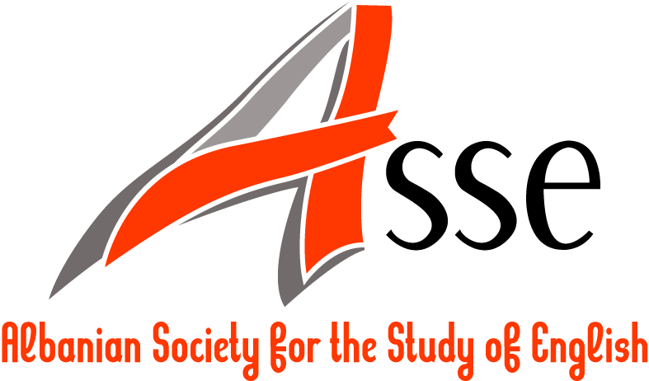

Nation, nationality, nationhood: What’s in a name?

Second ASSE International Conference on British and American Studies
organized in collaboration with the English School
of Canadian Institute of Technology

2-4 May 2013

Call for papers

Deadline for proposals: 31 January 2013

One of the Nation of many nations, the smallest the same and the largest the same,…

Song of Myself, Walt Whitman

Often defined in terms of commonness of culture, language, history, ethnicity, religion and spirit, the terms nation, nationhood, nationality seem to have become distant at a time when globalization, multiculturalism, intercultural or cross-cultural communication define the way we live with respect to ourselves, the others and the environment on the whole.

Although the terms are commonly used and defined by those who work in the field of Political Science, still they have been employed and have found expression in art, literature, history, sociology and many other social and cultural disciplines. The terms have usually become more emphatic in times of hardships for a country, especially during foreign invasion. Dulce et decorum est pro patria mori once summoned together people of different age and background to defend one’s country and culture.

Despite this, this sense of commonness as defined above is hard to maintain in present day society, when social, economic, demographic, technological and other developments take place in an eye shut. The exchange of cultures, the erasure of borders and boundaries have given way to a globalized world in which all cultures negotiate. Thus, in the present society a new feeling of commonness appears to define nation, nationality and nationhood.

We invite scholars to join us in the reconsideration of these concepts and hope to provide an intriguing ground for new perspectives and definitions of these concepts in the twenty-first century context.

Some possible topics the conference aims at addressing include:

- (Re)constructions of nationhood and national identity: past, present and future
- Representations of nationhood in art, literature, history and the media
- How do you respond to the principle “One nation, One state”?
- Utopia and dystopia: how different, how similar?
- National identity, national minority, national stereotypes
- Race, ethnicity, nationality, and language
- Self and the Other in the present-day nation
- Nationalism: how good, how bad?
- Interacting cultures: Diversity and harmony
- Disintegrating cultures: victimization, oppression and racism
- Theories of nation-building
- National heroes, myths and legends: uphold or debunk?
- Spatial and temporal representations of nation and nationality

Papers are welcomed from but are not limited to:

- British and Commonwealth Literature
- American Literature
- Literary Theory
- Literary Criticism
- Cultural Studies
- Intercultural Communication
- Communication Studies
- Media Studies
- Discourse Analysis
- Pragmatics
- Linguistics
- Semiotics
- Translation Studies
- Applied Linguistics

The conference language is English. Please send your abstracts (about 250 words) for papers (20 min) as an MS word attachment to the following Email-address by 31 January 2013:
nation@assenglish.org

Please follow the template to be found at http://www.assenglish.org/nation/cfp for the abstract submissions.

A selection of papers will be published in the journal in esse: English Studies in Albania, Vol. 4, No. 1, 2.

